Sand Ceremony
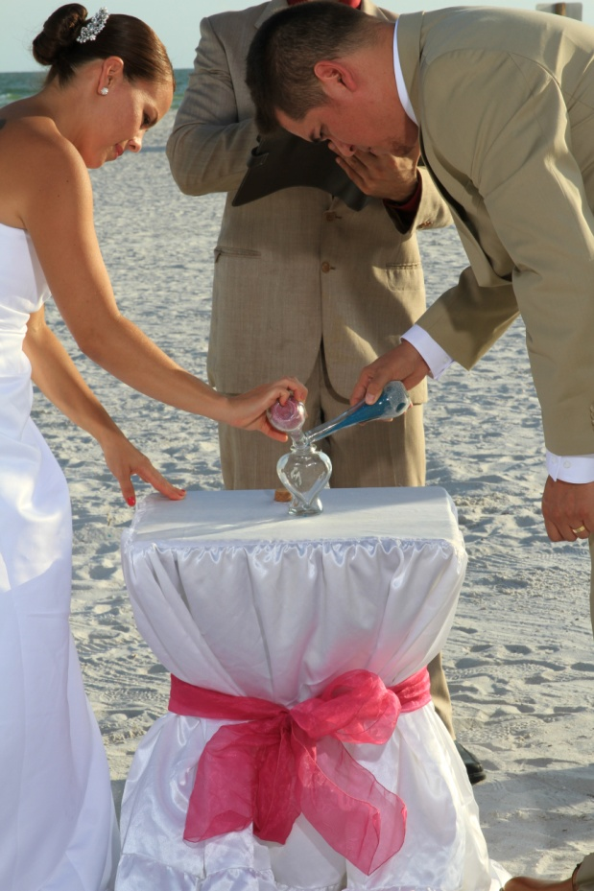
A Sand Ceremony or Blending of the Sand is a unique way to symbolize two lives becoming one. This is also a great way to incorporate children or family into the wedding ceremony.

Sand Ceremony 1
BRIDE and GROOM, today you join your separate lives together. The two separate bottles of sand symbolize your separate lives, separate families and separate sets of friends. They represent all that you are and all that you will ever be as an individual. They also represent your lives before today.
As these two containers of sand are poured into the third container, the individual containers of sand will no longer exist, but will be joined together as one. Just as these grains of sand can never be separated and poured again into the individual containers, so will your marriage be.

Sand Ceremony 2
GROOM and BRIDE you have just sealed your relationship by the giving and receiving of rings and this is a pledge between two people who agree that they will commit themselves to one another throughout their lives.
Today, this relationship is also symbolized through the pouring of these two individual containers of sand. One, representing you, GROOM and One Representing you BRIDE and all that you were, all that you are, and all that you will ever be.
As these two containers of sand are poured into the third container, the individual containers of sand will no longer exist, but will be joined together as one.
Just as these grains of sand can never be separated, our prayer for you today is that your lives together would be blended like the seven seas and may your love swirl around each other like the changing tides.

Sand Ceremony 3
Today, this relationship is symbolized through the pouring of these two individual containers of sand.
One representing you GROOM and all that you were, all that you are, and all that you will ever be and the other representing you BRIDE and all that you were, all that you are, and all that you will ever be.
As these two containers of sand are poured into the third container, the individual containers of sand will no longer exist, but will be joined together as one.
Just as these grains of sand can never be separated and poured again into the individual containers, so will your marriage be.

Sand Ceremony 4
Three colors of sand are layered in a vase to symbolize the importance of the individuals within the marriage and the joining of the two lives into one entity.
The sculpture begins with a layer of neutral sand to symbolize that the marriage is grounded.
The next layers are the individual colors representing the bride and groom which symbolizes that the foundation of the marriage is based on the strength of the individuals.
The final layer is the bride and groom’s colors combined to symbolize the joining of their lives as one in marriage.

Family Sand Ceremony 5
BRIDE and GROOM, today you are making a life-long commitment to share the rest of your lives with each other and honor your children as well.
Your family relationship is symbolized through the pouring of these individual containers of sand; one, representing you, BRIDE and all that you were, all that you are, and all that you will ever be, one representing you, GROOM, and all that you were and all that you are, and all that you will ever be and another container for each child.
There are children who will share in this marriage.
The gathering of this new family will have a deep influence upon them.
We realize that in order for the home to be a happy one, it is essential that there be love and understanding between the children and the adults being married.
As you each hold your sand the separate containers of sand represent your lives to this moment; individual and unique.
As you now combine your sand together, your lives also join together as one family.
You may now blend the sand together symbolizing the uniting of the children and bride and groom into one.
Just as these grains of sand can never be separated and poured again into the individual containers, so will your marriage and your family be.

Family Sand Ceremony 6
Four colors of sand are layered in a vase to symbolize the importance of the individuals within the marriage and the joining of the two lives into one entity.
The sculpture begins with a layer from each mother. This is to symbolize that the marriage is grounded by each of their families.
The next layers are the individual colors representing BRIDE and GROOM, which symbolizes that the foundation of the marriage is based on the strength of each other as individuals.
The final layer is BRIDE and GROOM’s colors combined to symbolize the joining of their lives as one in marriage.

Family Sand Ceremony 7
Each of you in attendance this evening were asked to be here because you hold a special place in Groom’s and Bride’s life.
You came to honor and witness their love and commitment. GROOM and BRIDE wanted to make each of you a tangible part of this ceremony therefore, as each of you arrived this evening and entered into this scared space you were asked to spoon a small amount of white sand into a container.
They chose white sand because of the purity of your love and support to them and their family.
GROOM and BRIDE have chosen varying shades of blue sand for themselves and for Children’s names.
Each shade of blue represents each one of them.
These blues stand for the peace and calm they feel when together. It stands for the ocean waters deep and full of mystery and beauty.
Water that sustains all of life…
Water a great conductor of energy…
Water a simple element yet it can change and adapt to any form or environment.
At this time I ask you, GROOM and BRIDE to pour some of your sand into the container because your marriage is the foundation of your family.
Now, I ask that (Children’s names) join you in pouring their sand together with yours to create a beautiful flow of love and energy.
Lastly, I will fill the remainder of the container with more white sand.
This white sand stands for Universal Love…
A love that is eternal and never-ending.
(Family names) please hold hands.
I ask all in attendance to join me in a prayer of blessing upon this beautiful family.

Family Sand Ceremony 8
BRIDE and GROOM, today you are making a life-long commitment to share the rest of your lives with each other.
Your relationship is symbolized through the pouring of these individual containers of sand; one, representing you, BRIDE and all that you were, all that you are, and all that you will ever be, and the other representing you, GROOM, and all that you were and all that you are, and all that you will ever be.
As you each hold your sand the separate containers of sand represent your lives to this moment; individual and unique. As you now combine your sand together, your lives also join together as one family.
At this time, I would invite the parents of BRIDE and GROOM to come forward. These four vials of sand represent the bride and groom and each family.
You may now blend the sand together symbolizing the uniting of the two families into one.
Just as these grains of sand can never be separated and poured again into the individual containers, so will your marriage and your families be.

Family Sand Ceremony 9
Parents, today you are making a life-long commitment to share the rest of your lives with each other and honor your children as well.
Your family relationship is symbolized through the pouring of these individual containers of sand; one, representing each one of you, all that you are, and all that you will ever be.
There are children who will share in this marriage. The gathering of this new family will have a deep influence upon them.
We realize that in order for the home to be a happy one, it is essential that there be love and understanding between the children and the adults being married.
As you each hold your sand the separate containers of sand represent your lives to this moment; individual and unique.
As you now combine your sand together, your lives also join together as one family.
You may now blend the sand together symbolizing the uniting of the children and groom/bride and groom/bride into one.
Just as these grains of sand can never be separated and poured again into the individual containers, so will your marriage and your family be. With this marriage, these two families are joined.
(To the kids:)
Each of you are now a resource into which, as family members, you may come to, throughout your life times, for direction, meaning, and love.
Your Parents strive to provide not only the basic needs, but a nurturing and loving environment in which each of you find the confidence to reach the highest goals of your hearts, minds, and spirits.
This is part of their vision of what your family is. Do you each accept the responsibility of being an important part in the building of this family, and to forever contribute your best efforts to maintain the closeness and strength?
If so, say, “We do.”

